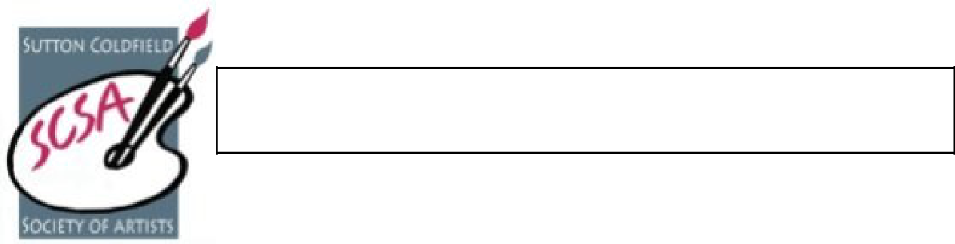
Sutton Coldfield Society of Artists

We are a welcoming group who enjoy meeting like-minded artists to discuss artwork, in all its forms, exchange ideas and share information on materials and methods. The Society provides an opportunity to gain knowledge and experience and, hopefully, make new friends.

The Society meets throughout the year. During the autumn, winter and spring the Saturday meetings are a mixture of demonstrations and practical art sessions. During the summer months we take advantage of the warmer weather and enjoy sketching days out. Partners and friends are also welcome to come on our excursions or join our Christmas celebrations.

Currently, the Saturday meetings consist of a morning session (10 am – 1 pm) and afternoon session (1.45 pm – 3.30 pm) in Room 4 at the Methodist Church Hall, South Parade, Sutton Coldfield B72 1RB. The demonstrations are also open to members of the public paying a temporary membership fee of £3.00.

At the practical art sessions, still-life arrangements can be set up (organized by members) and usually a clothed model is available for portrait work. Occasionally, special tutored workshops are arranged at a small charge.

You may work in whatever medium you choose; the set themes are not obligatory, and members are free to work on their own projects. You can choose the length of time to be there, come for just the morning, or afternoon, or if you wish, attend for the whole day (bring something for lunch).

All members are entitled to submit original works of art (paintings, sculptures, ceramics, textiles, collages, etc.) to the exhibitions we hold twice a year in Spring and Autumn. There is no obligation to submit for exhibitions.

Ordinary membership is £30 per annum (£31 if paying by cheque) payable on 1st November.
Student membership is £15 per annum (£16 if paying by cheque)
(from age 18 - 25, proof of full-time study needed).

For more information, please contact the membership secretary.
Email: lyndahoar@btinternet.com Tel: 07821 910272
SCSA Membership Application Form

Please complete the following:

Name……………………………………………………………………………………………….

Address……………………………………………………………………………………………

……………………………………………………………………Post Code……………………

Tel: No: ……………………………Email: ……………………………………………………...

If you wish to set up a Standing Order, then please inform your Bank using the details at the bottom of the form.

You can also use the Bank details on the form to pay electronically. Please inform the Treasurer when you do this on: deborah.s.hodgson@gmail.com

Then send the rest of the form (or a cheque with the completed form) to: Membership
Secretary, 17 Walsall Road, Four Oaks, Sutton Coldfield, West Midlands. B74 4ND. Email: lyndahoar@btinternet.com Tel: 07821 910272

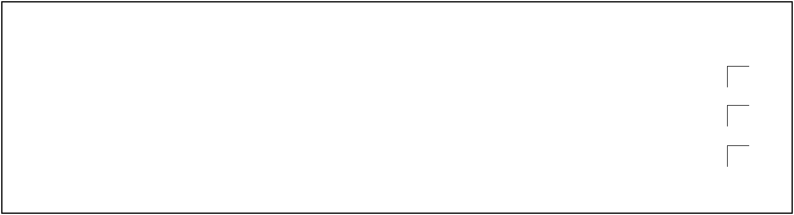
Full membership is £30* (*£31 if paying by cheque)
Student membership (18—25) is £15* (*£16 if paying by cheque)
Please tick the relevant boxes and cross out the items not applicable to you.

I will set up a Standing Order for £30/£15………………………………………….

Cheque payment - £31/£16 cheque enclosed …………………….……………...

Electronic payment for £30/£15 …………………………………………………….


I agree that the information given above may be stored on the group’s data base and retained in order to contact me about SCSA activities and events. It will only be used for this purpose and not passed on to anyone else………………………………………………………………………………….………………….

I do / do not wish to share my details, as above, with other members of the SCSA ………..

Signature…………………………………………………….

Date…………………………….


To pay electronically or set up a Standing Order then the details you may need are:

Lloyds Bank

Sort Code: 30-98-37

Name of Account: Sutton Coldfield Society of Artists

Account Number: 02080961

Reference: Your name

Standing Orders should be paid annually by 1st December

