Summer Painting Days

2025

Join fellow members sketching or painting
at these venues. The venues are all quite near to encourage more to join us. If you are new to this, there is always someone to help. We can always arrange car share to venues further away. More information can be found on the websites for each venue
or contact Chris Bowden
Email - citbowden171@gmail.com
tel - 07779981878
Thursday 10th July
Saturday 12th July
Wednesday 16th July
Thursday 24th July
Wednesday 30th July
Thursday 7th August
Wednesday 13th August

An email, call or txt the day before would be useful to know if you are going to the venue.
Meeting time will be 10.30 in car park.

Thursday 10th July
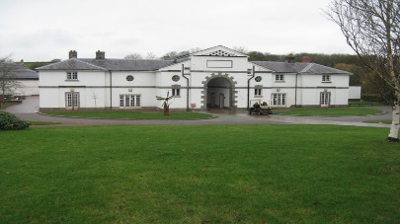
Middleton Hall
Tamworth B782AE

Saturday 12th July
Urban Sketching with Tim Griffiths at the Fuse Festival in Lichfield. For more information contact Tim Griffiths
canonvela@gmail.com
07850799791

Wednesday 16th July
Botanical Garden
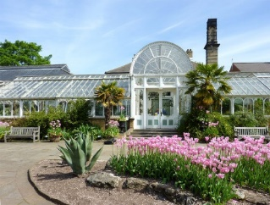
Westbourne Rd B15 3TR

Thursday 24th July
Fradley Junction
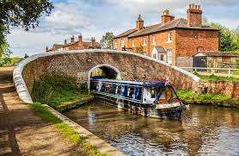
and Nature reserve DE13 7DN

Wednesday 30th July
Shugborough Hall
ST17 0UP
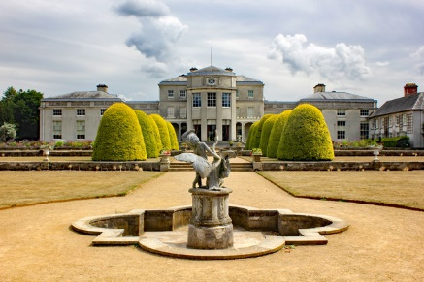

Thursday 7th August
Elford Gardens Church Rd Elford B79 9DA
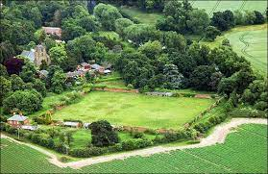

Wednesday 13th August
Wheats Garden Centre
Chester Rd WS9 0UP

Lots of views around the lakes.

